
1. I have done the user access roles, there are 3 roles admin, scheduler and driver. Below is the schedulers dashboard.
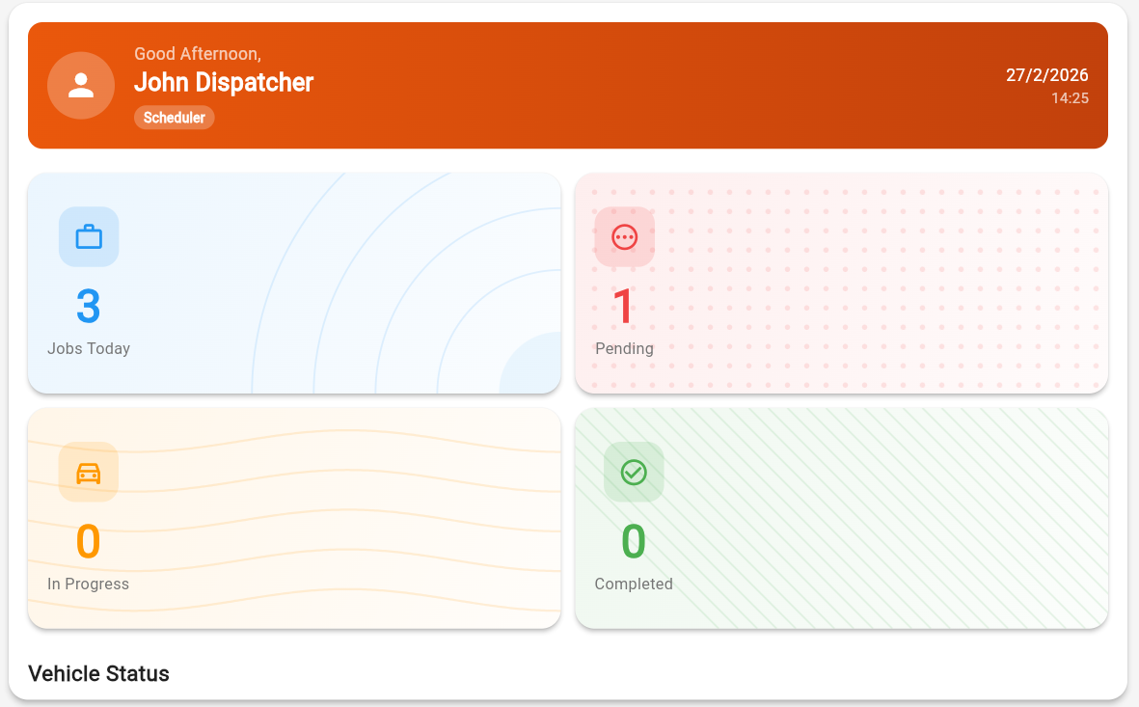

2. This is the weekly view scheduler, improvements include more visible text and color change of pending to have red warning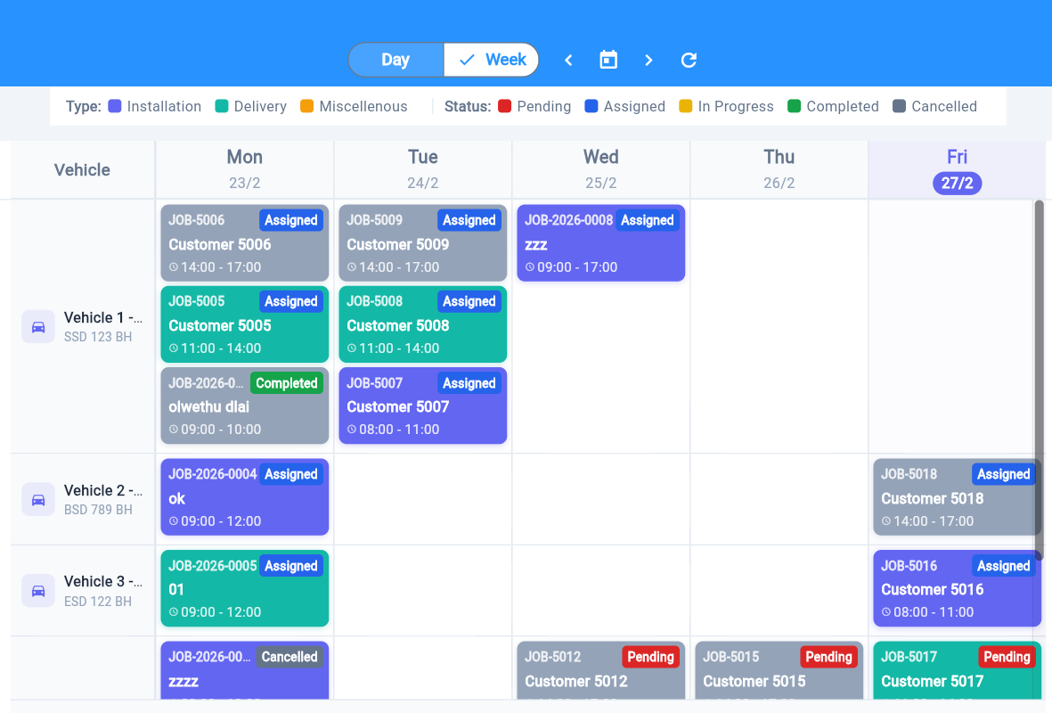
3. This is the drivers dashboard it shows jobs assigned to that particular driver and driver can update the status of that job.
